• Unit Testing (Code Check):
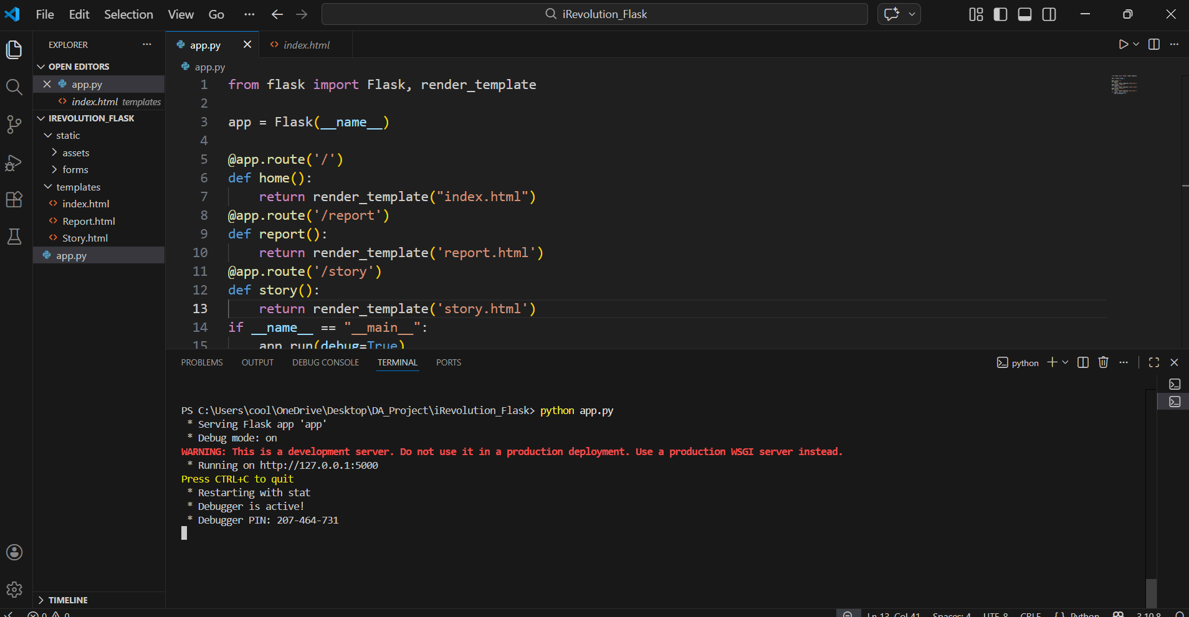
- Label: "System successfully initialized on local server."
• Functional Testing (Page Navigation):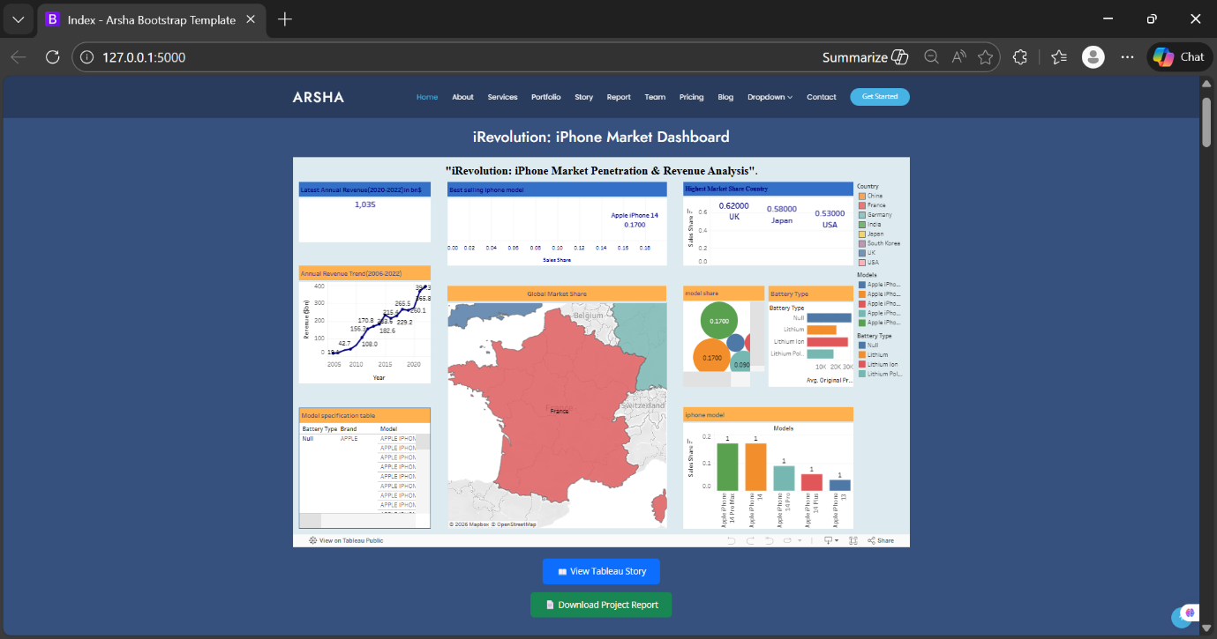
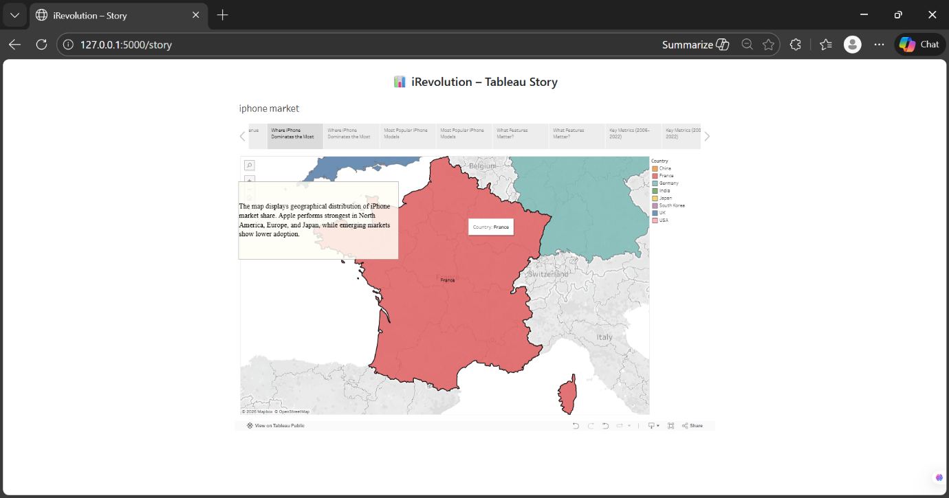
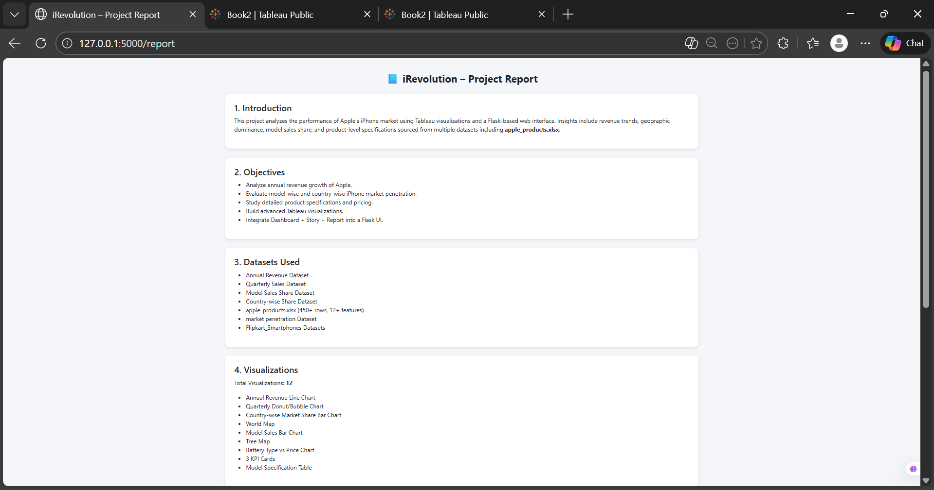
- Label: "Verified that all navigation links work and pages load correctly."
• Data Visualization Testing:
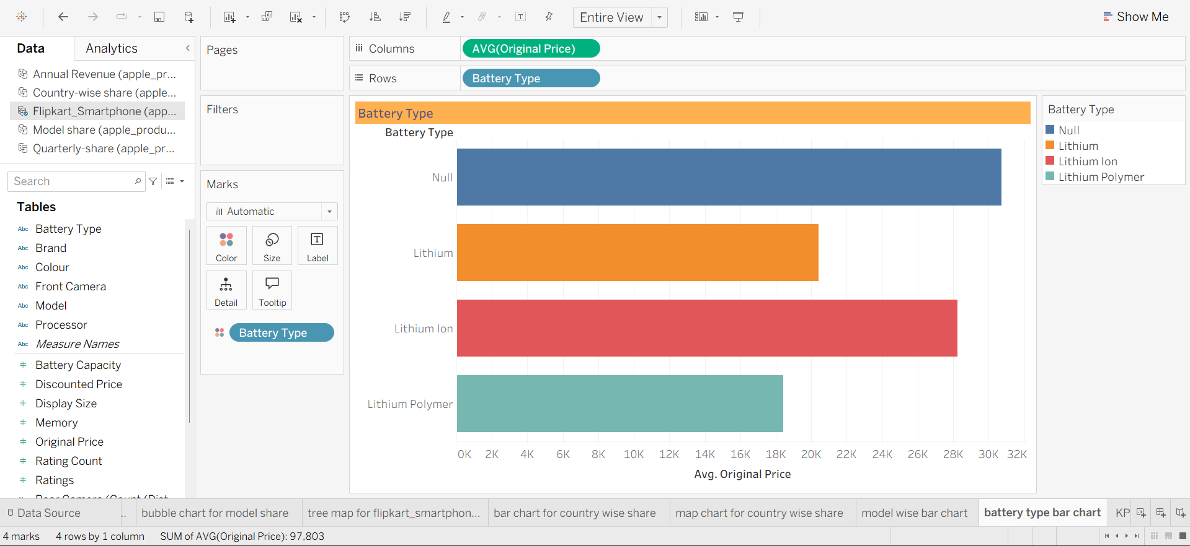
- Label: "Interactive Tableau elements verified and responsive."

